Home Page – Hospital Management System

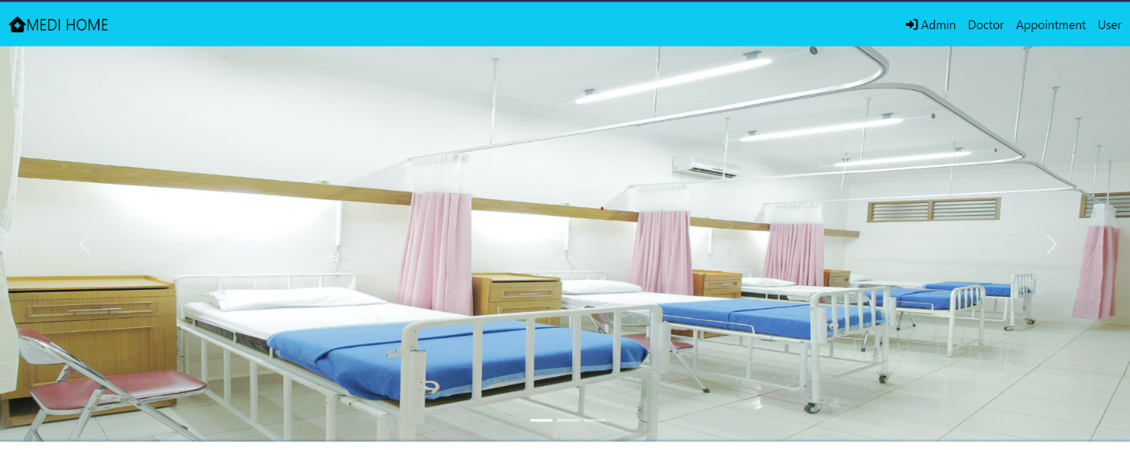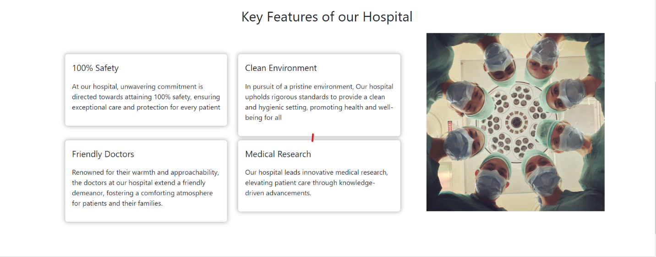

Email: [admin@gmail.com](mailto:admin@gmail.com)

Password: admin

Admin Login Page

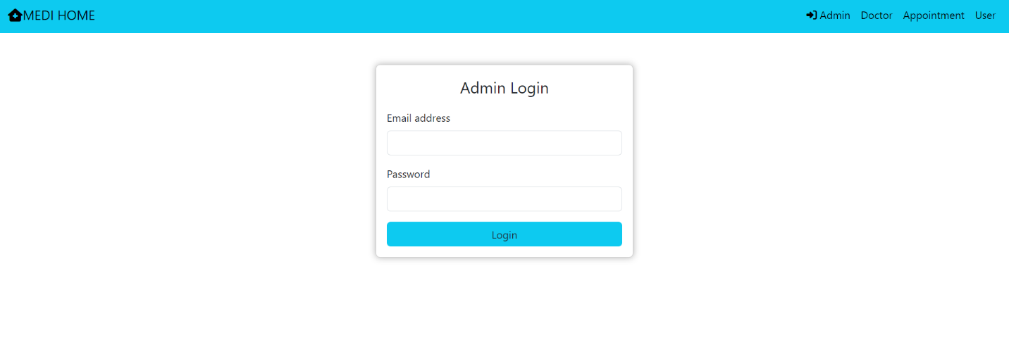

Login Page in case of wrong Credentials: #Same type of message will be shown for all pages

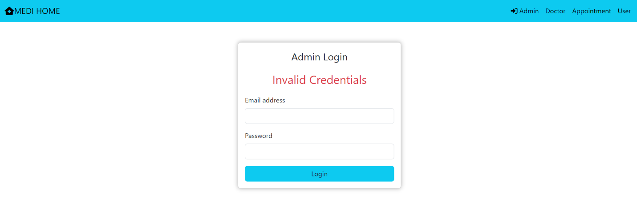

Admin Home Page:

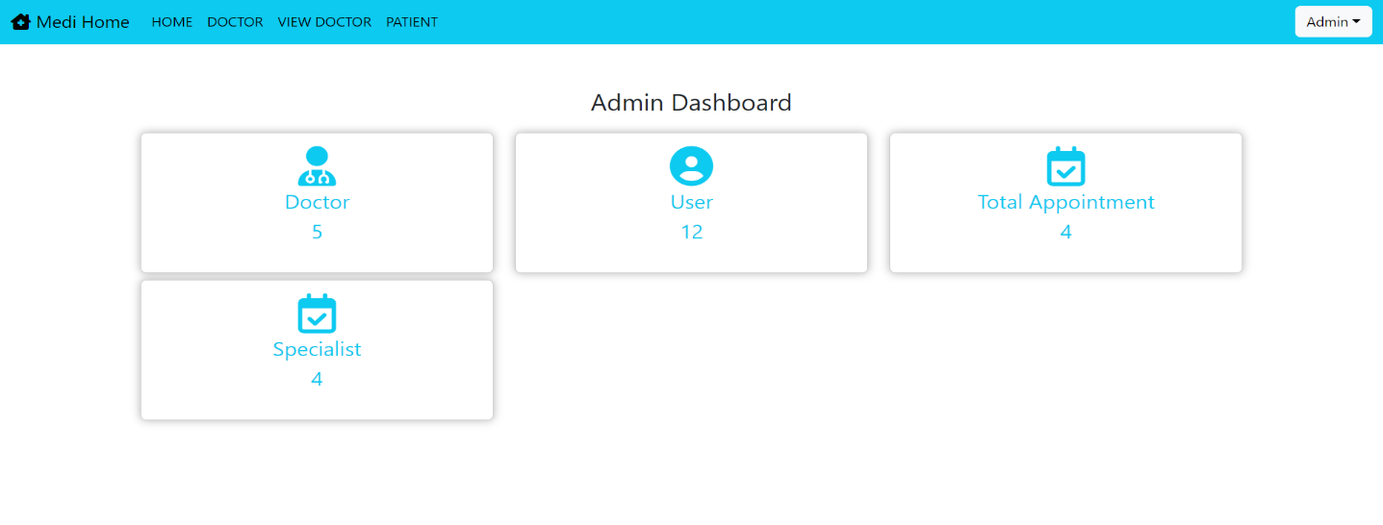

Admin Home page gives the information about the number of doctors, users, appointments, and specialists available in the hospital.

Add Doctor performed by admin: Using Doctor on Navigation bar.

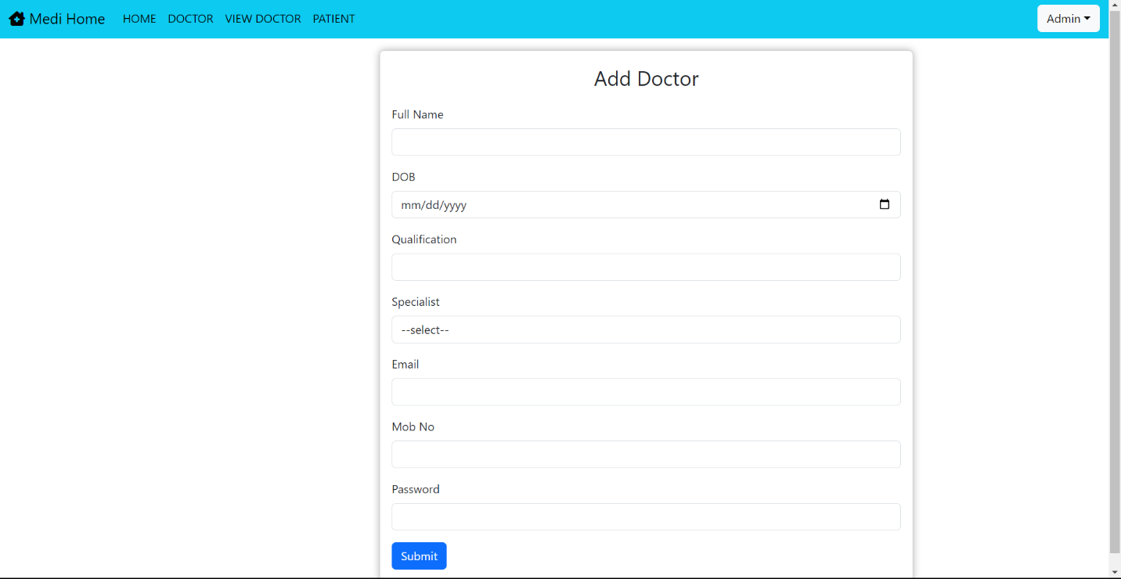

View Doctor only restricted to admin : 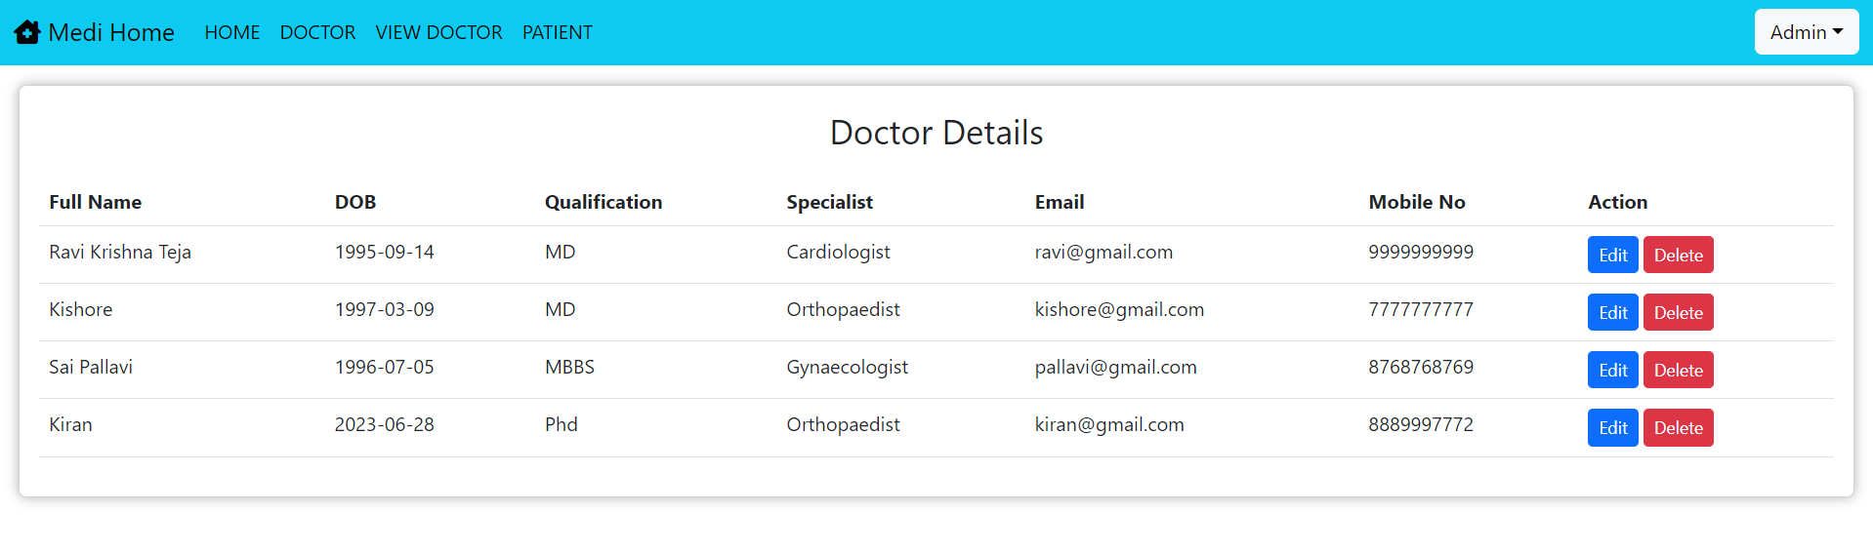

Editing Doctor Kiran’s details:

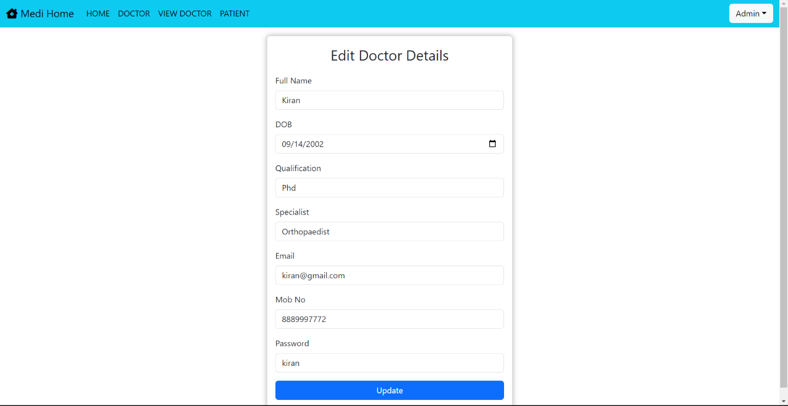

View doctor page after editing Kiran’s DOB from 2023 to 2002:

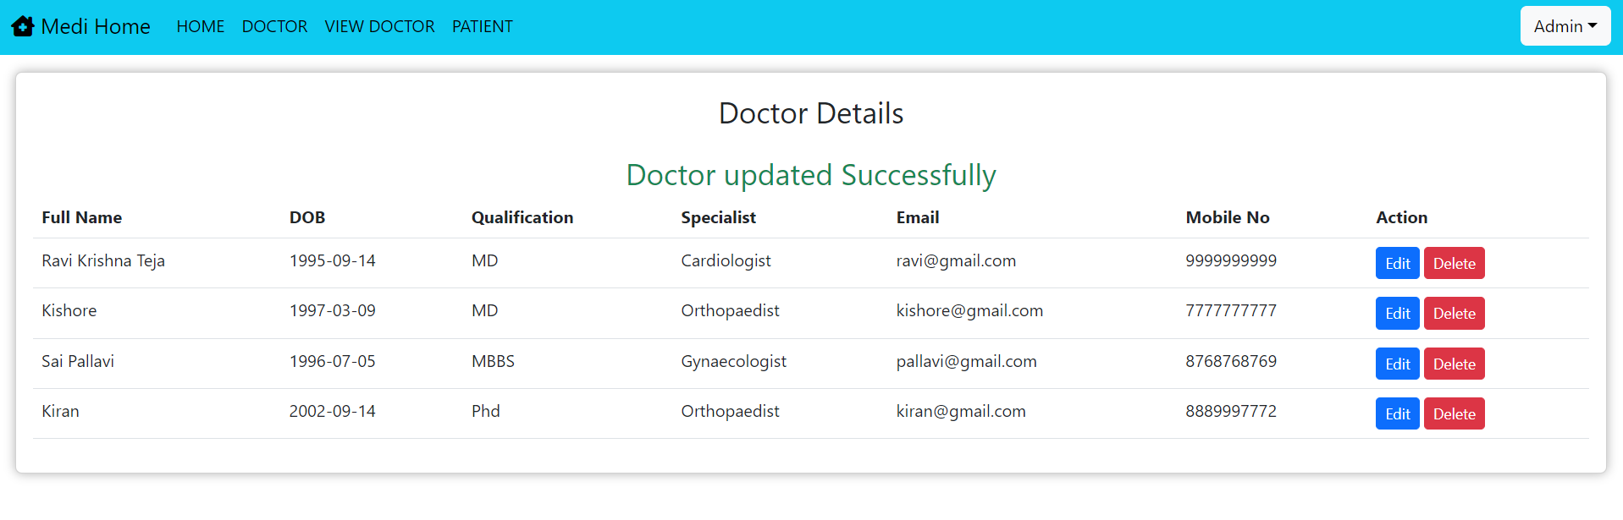

Admin can also, delete any particular doctor from the hospital, just by clicking on delete button on the view doctor page

Admin Can view the information about all the patients visited the hospital using patient page:

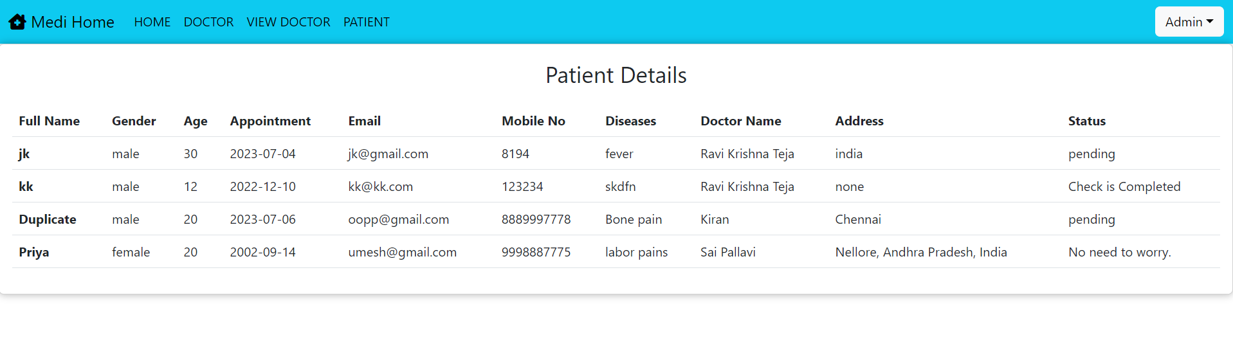

Add Specialist:

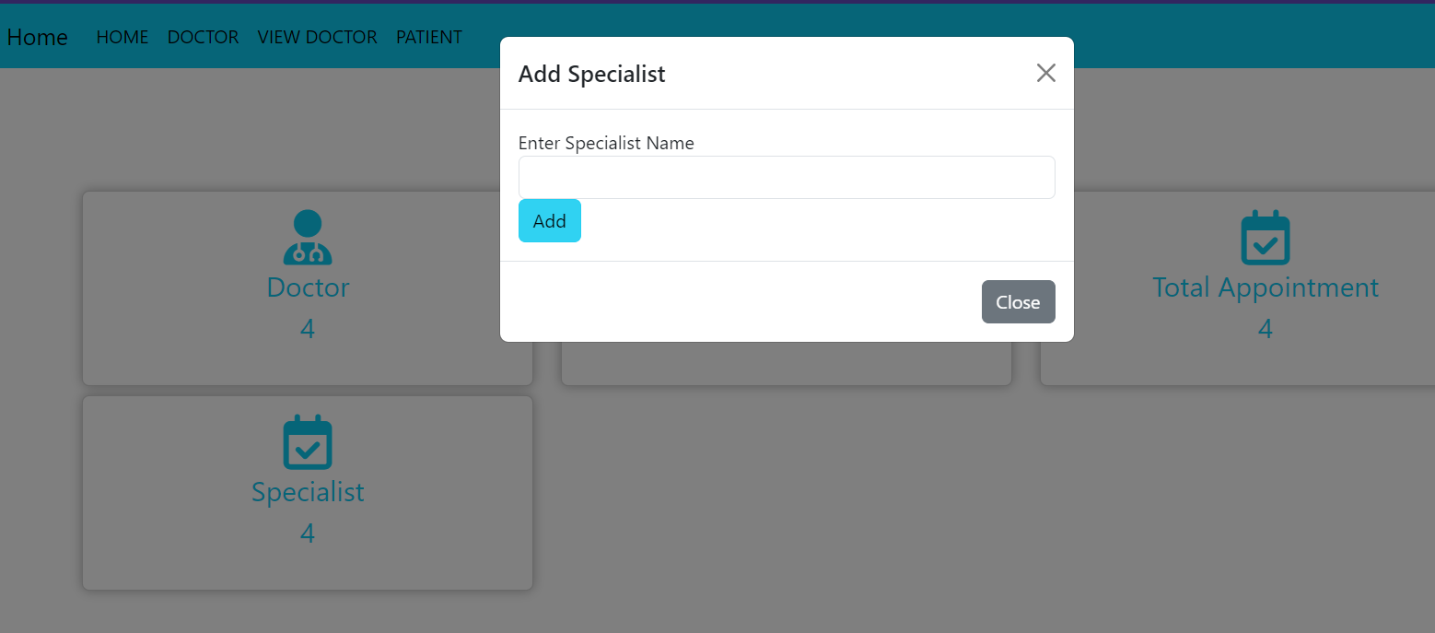



Specialist Added message with increase in count of specialists on home page:

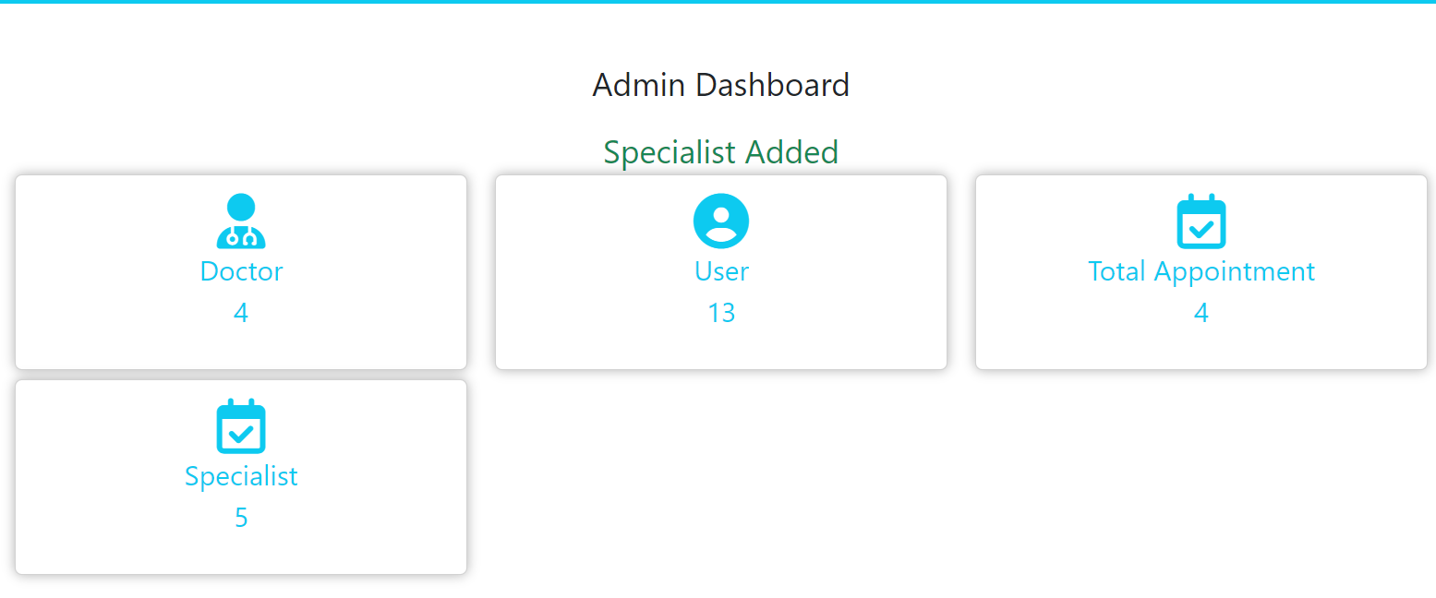

Admin Logout:

Using the admin drop down box situated in top right corner

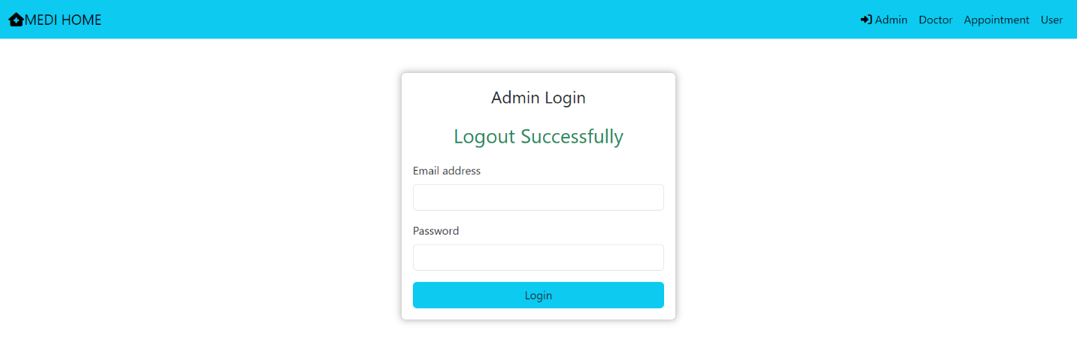

Doctor Login Page: 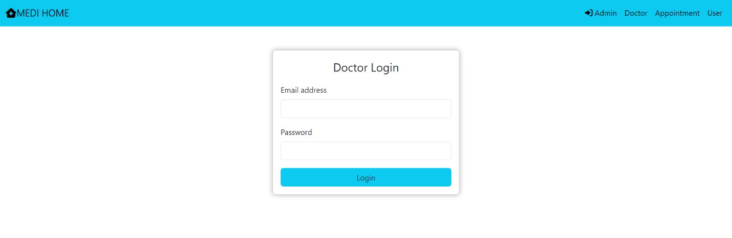

Doctor Home Page: 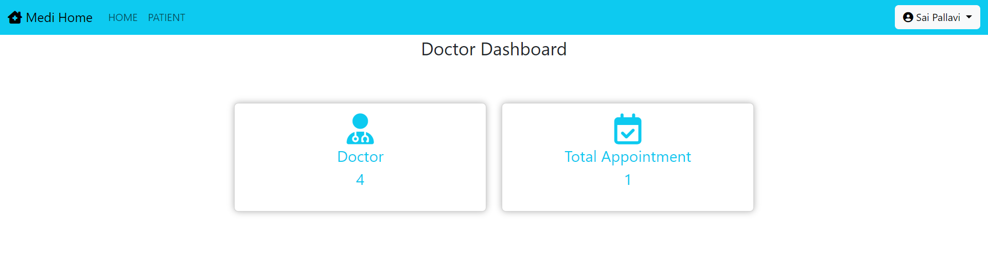

Patient Details assigned for the particular doctor:

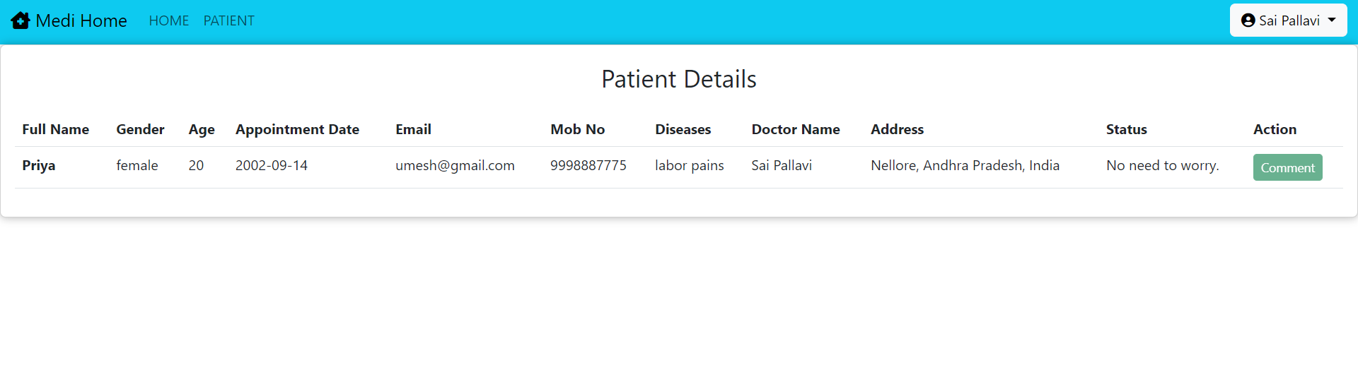

Edit Profile page of the doctor, on the top-right drop down button:

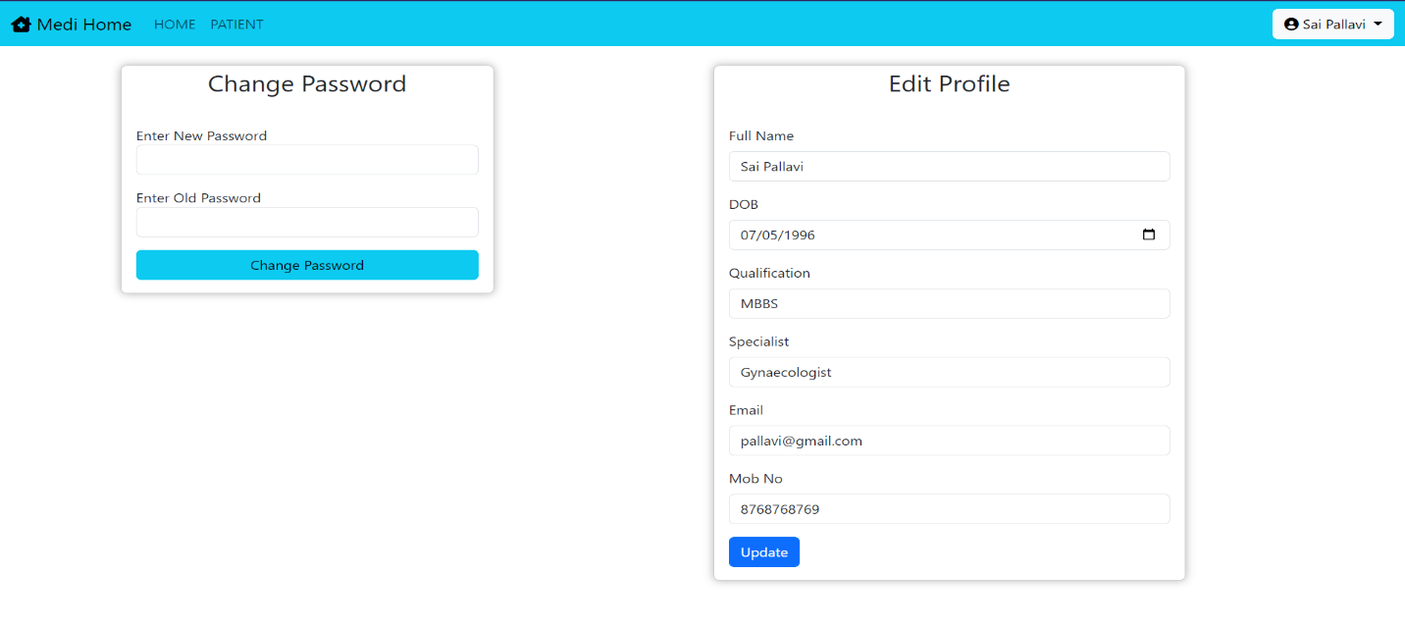

Success Message after changing the password of the doctor:

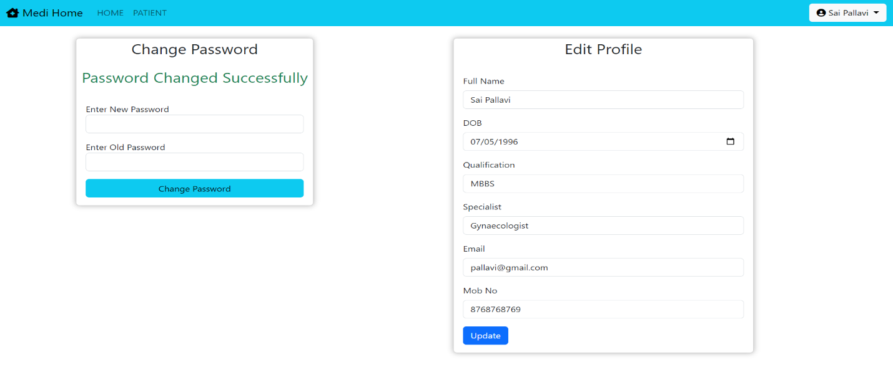

Doctor Logout (Using drop down on top right corner):

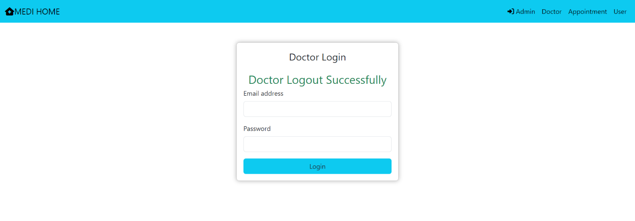

User Login Page:

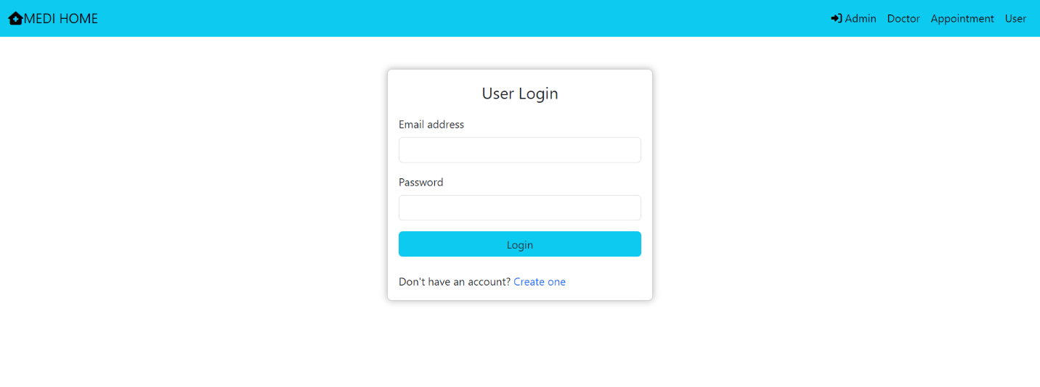

User Registration Page after clicking the create one link on user login page:

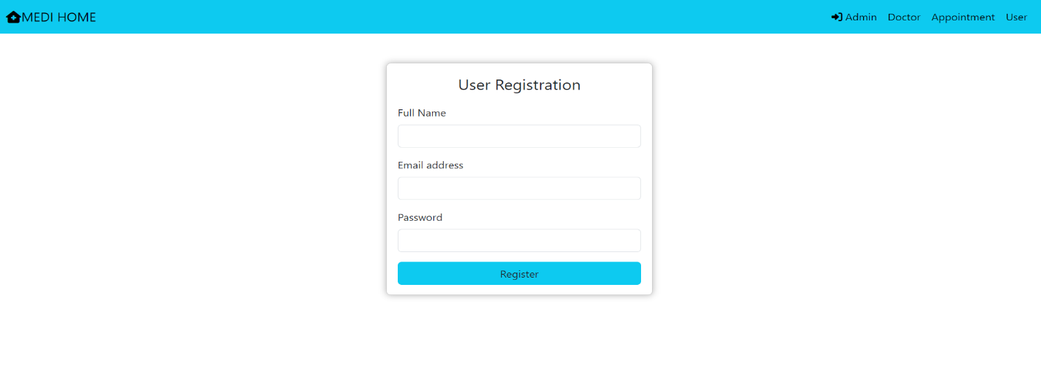

Registration Success Message:

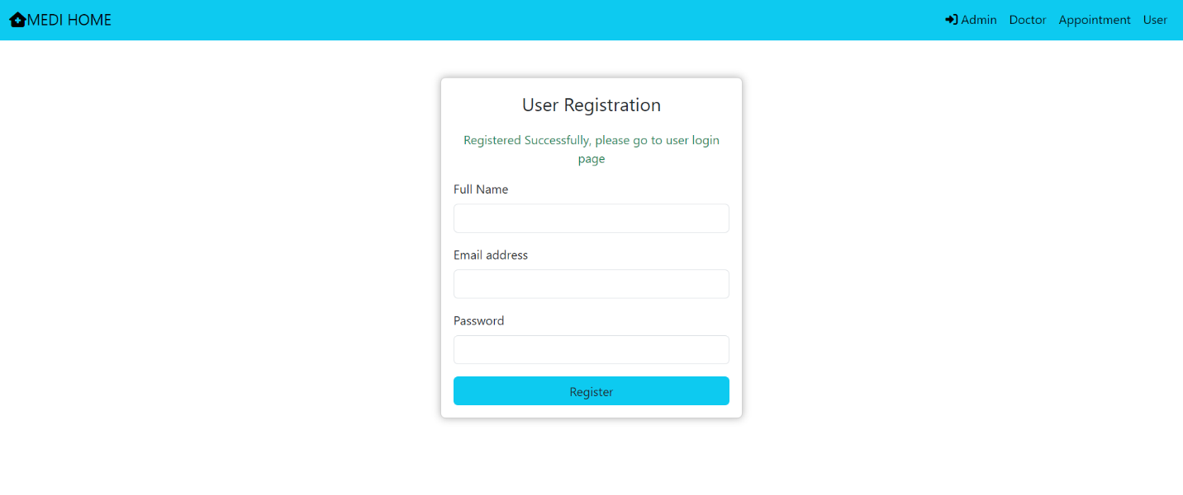

User Home Page after logging in using user credentials:

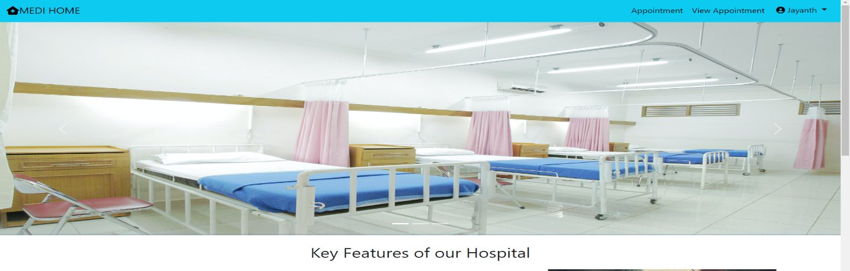

User Appointment Page:

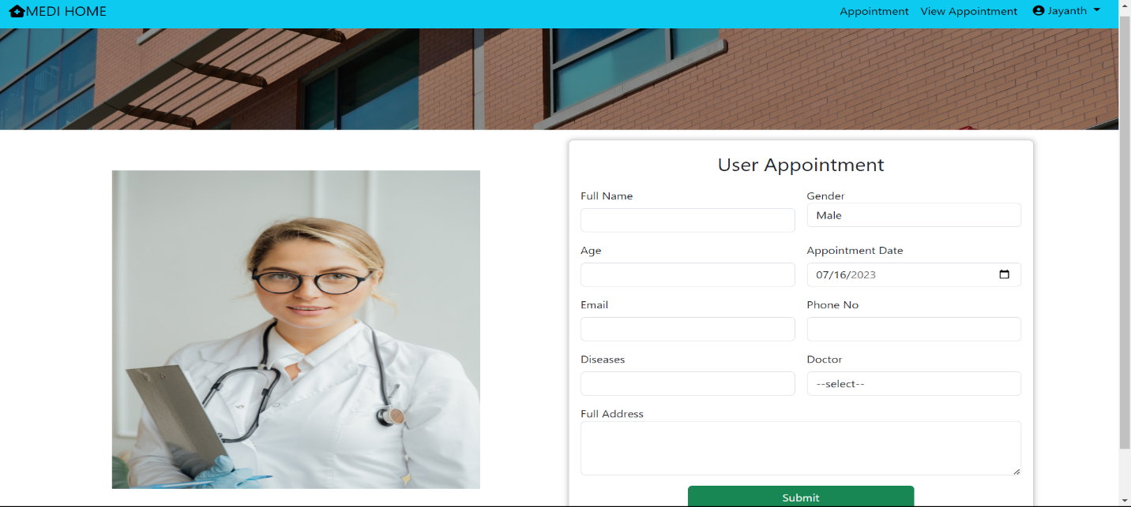

View Appointment Page ( List of appointments created by the particular user to any doctor which will add as patient details to that selected doctor)

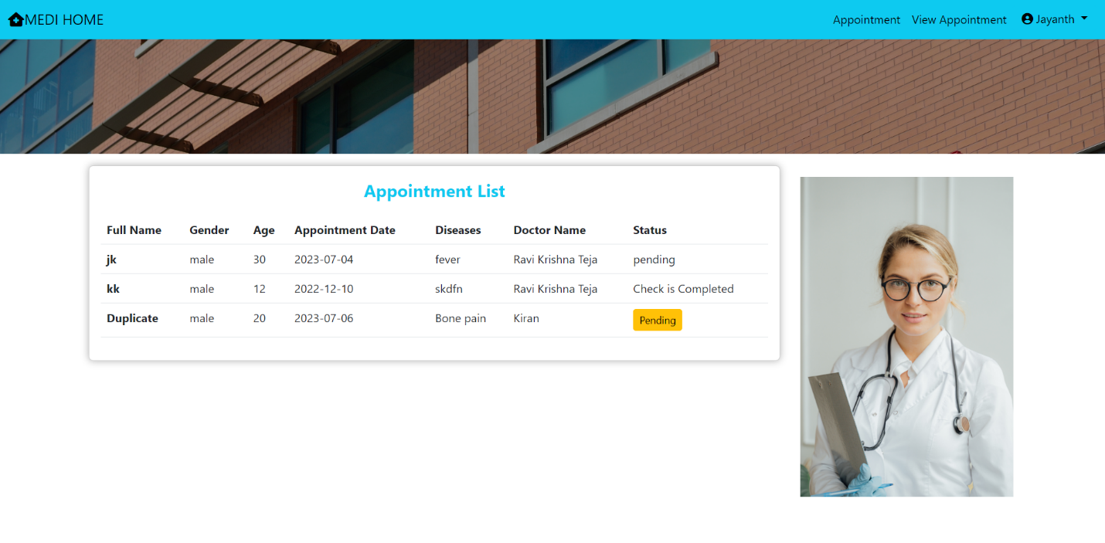

Change Password page for the user: (Drop down Option on the top – right corner)

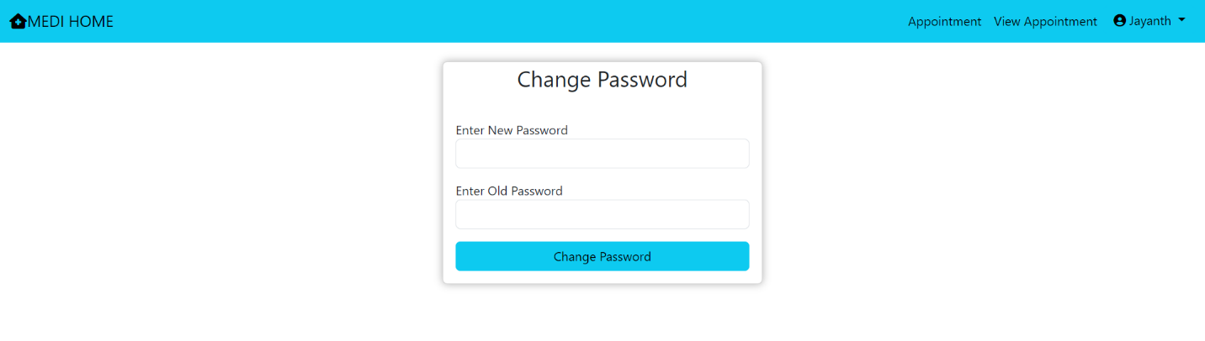

User Logout Message: (Drop down option)

